Service Contract

cs.pay.ebs.Payments_1.0

Author: Marwan Zakhia

Creation Date: April 28, 2015

Last Updated: April 28, 2015

Version: 0.1 - Draft

1. **Title, Subject, Last Updated Date, Reference Number**, **and** **Version** are marked by a Word Bookmark so that they can be easily reproduced in the header and footer of documents. When you change any of these values, be careful not to accidentally delete the bookmark. **You can make bookmarks visible by selecting Tools->Options…View and checking the Bookmarks option in the Show region.**

**Approvals:**

|  |  |
| --- | --- |
| Mohammad Abumalloh |  |
| Osama AlDameri |  |

1. To add additional approval lines, press [Tab] from the last cell in the table above.
2. You can delete any elements of this cover page that you do not need for your document.

# Document Control

## Change Record

5

| Date | Author | Version | Change Reference |
| --- | --- | --- | --- |
| 14-April-2015 | Marwan Zakhia | 0.1 | Initial or Draft Version |
|  |  |  |  |
|  |  |  |  |

## Reviewers

| Name | Position |
| --- | --- |
| Mohammad Abumalloh | SBM Project Manager |
| Osama Al Dameri | EMAD Project Manager |
|  |  |
|  |  |

Contents

Document Control 2

Change Record 2

Reviewers 2

Introduction 5

Purpose 5

Intended Audience 5

Document Summary 5

Document References 5

Assumptions and Constraints 5

Non-Functional Details 5

Overview Of operations 1

Interface Definition 3

Operation – uploadPayment 4

Expected Errors 2

Operation –loadPayment 2

Expected Errors 2

Operation – confirmPayment 4

Expected Errors 2

Operation – notifyPayment 3

Expected Errors 2

Appendix 3

1. To update the table of contents, put the cursor anywhere in the table and press [F9]. To change the number of levels displayed, select the menu option Insert‑>Index and Tables, make sure the Table of Contents tab is active, and change the Number of Levels to a new value.

# Introduction

The purpose of this task is to assemble all the information that is required to describe the design of a software component into a complete Design Specification. This task is not a substitute for executing the individual design tasks. This specification work product can serve as a structure for completing the design for each component by providing pointers back into the Design Tasks:   
- DS.040 Develop Design Architecture Description  
- DS.080 Design Software Components  
- DS.090 Design Data  
- DS.100 Design Behavior  
- DS.130 Design User Interface

## Purpose

The purpose of this document is to serve as a description of the capabilities offered by the service as well as the requirements placed on the client by the service e.g. security requirements. It also provides, at a high level, the technical solution. This document will describe both the functional and non-functional aspects of the service. This document will not describe the technical aspects of the service. This information can be viewed in the Technical Specification for the service.

## Intended Audience

The intended audience for this document is:

* Architects
* Developers
* Testers

## Document Summary

This document is produced after service identification and documentation thereof in the solution blueprint.

This document covers the following areas:

* Service Description
* Service Design & High Level Implementation details
* WSDL
* Enterprise Business Messages (EBM)

## Document References

The following documents were considered in the authoring of this service contract:

* Solution Blueprint Document
* SADAD integration Document

## Assumptions and Constraints

* The provider system is assumed to be accurate in its responses
* The provider system is considered to be stable
* Service availability is constrained by the availability of the provider system

## Non-Functional Details

### General Properties

|  |  |
| --- | --- |
| **Service Name** | Payments |
| **Service Type** | External Business Service (EBS) |
| **Capability** | cs.pay |
| **Function** | Provide access to Payments details and functions. |
| **Critical Dependencies** | The provider system provides timely access to accurate transaction information |
| **Dependencies on Other SOA Services** | None |
| **Other Dependencies** | The provider system |

### Quality of Service

| **Availability** | 24 hours a day, 7 days a week |
| --- | --- |
| **Reliability** | Not Applicable |
| **Throughput** | Up to approximately 5kB of data in the given response time for a search |
| **Response time** | uploadPayment < 20 seconds  loadPayment < 10 seconds  confirmPayment < 10 seconds  notifyPayment < 10 seconds |

## Overview Of operations

| **Operation** | **Description** | **Communication Style** | **Inputs** | **Outputs** | **Expected Errors** |
| --- | --- | --- | --- | --- | --- |
| uploadPayment | Upload a batch of payments that are done through non-sadad channel | Acknowledge Synchronous Request - Response | Payment info | Acknowledge flags | Invalid request data  Provider system communication errors  Provider system functional errors  Unexpected IT related errors |
| loadPayment | Upload Payments done through non-sadad channel to sadad in real time transaction | Synchronous Request - Response | Payment Info | Satus code  Message code | Invalid request data  Provider system communication errors  Provider system functional errors  Unexpected IT related errors |
| confirmPayment |  | Synchronous Request - Response | Success record counts  Error records count | Acknowledge flags | Invalid request data  Provider system communication errors  Provider system functional errors  Unexpected IT related errors |
| notifyPayment | Biller is notified by a real time basis of the payment done through SADAD | Synchronous Request - Response | BillingAccount  PaymentID | Acknowledge flags | Invalid request data  Provider system communication errors  Provider system functional errors  Unexpected IT related errors |

## Interface Definition

### WSDL

The service interface definition in graphical WSDL format is presented below in Figure 1.

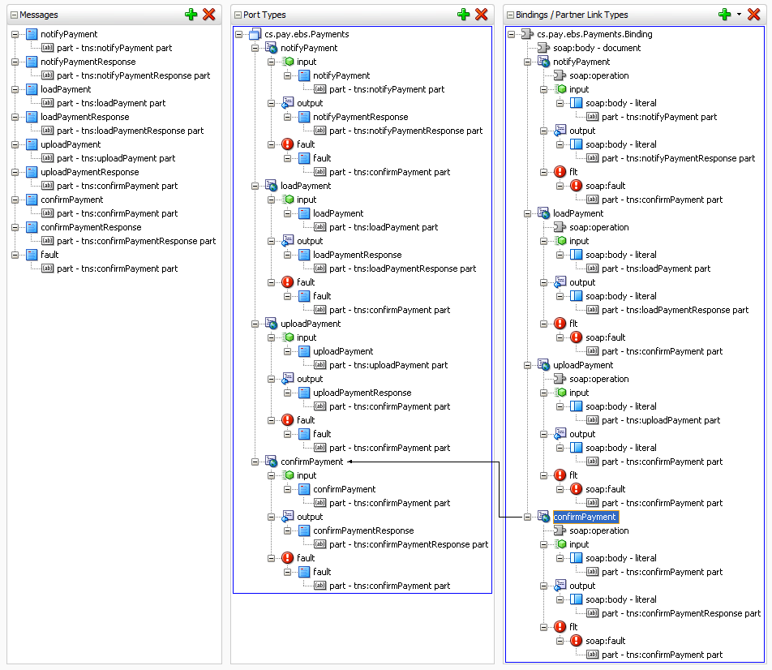

Figure – Service Interface WSDL

## Operation – uploadPayment

### Overview

| **Communication Style** | Acknowledge Synchronous request-response |
| --- | --- |
| **CRUD Operation/s** | Update |
| **Idempotent** | Yes |
| **Atomic** | Yes |
| **Transaction Required** | No |
| **Transaction Coordination Required** | N/A |
| **How Transaction Coordination Achieved** | N/A |

### Functional Overview



Figure : Functional Overview

### Security

The consumer will provide credentials enabling the consumer to consume the *uploadPayment* operation using Client Certificate Authentication over TLS.

### Input EBM

The input EBM is ***uploadPayment*** and is in the XML namespace ***http://www.AlMajdouie.sa/ebs/cs.pay.Payments***. The figure below depicts this message.

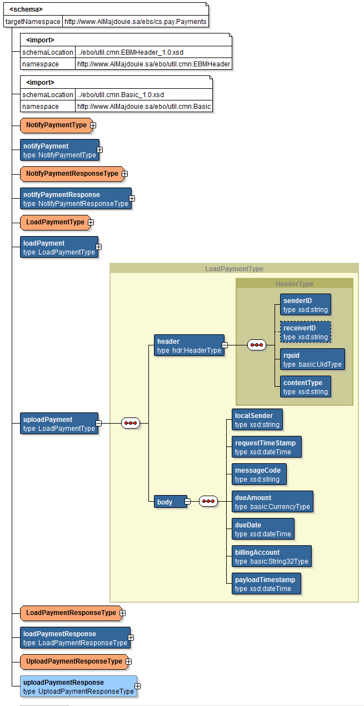

Figure : uploadPayment input EBM

### Output EBM

The output EBM is ***uploadPaymentResponse*** and is in the XML namespace ***http://www.AlMajdouie.sa/ebs/cs.pay.Payments***. The figure below depicts this message.

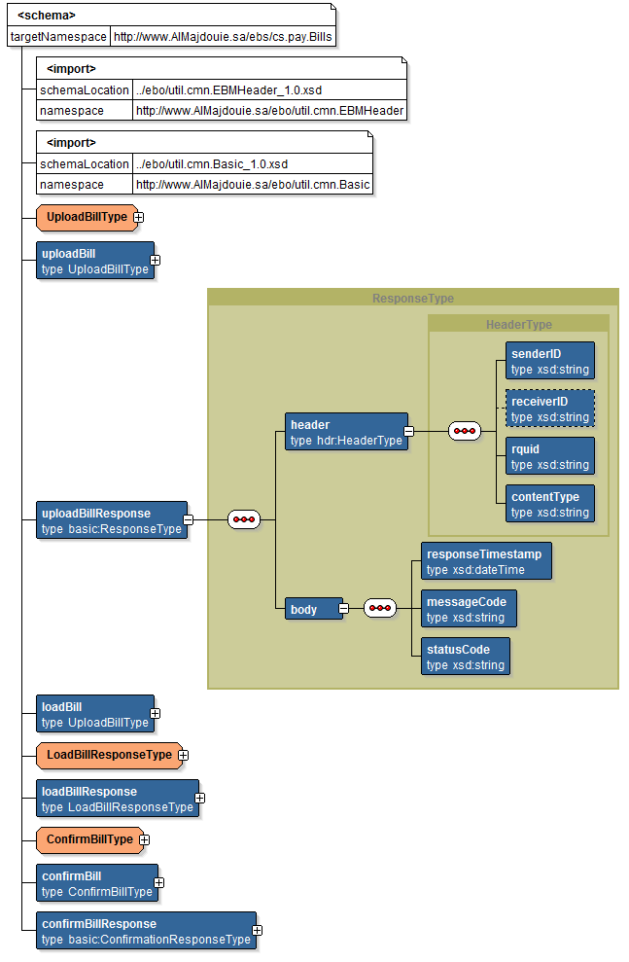

Figure : uploadPaymentResponse output EBM

### Fault EBM

The fault EBM is ***fault*** and is in the XML namespace ***http://www.AlMajdouie.sa/ebo/util.flt.Fault***. The figure below depicts this message.

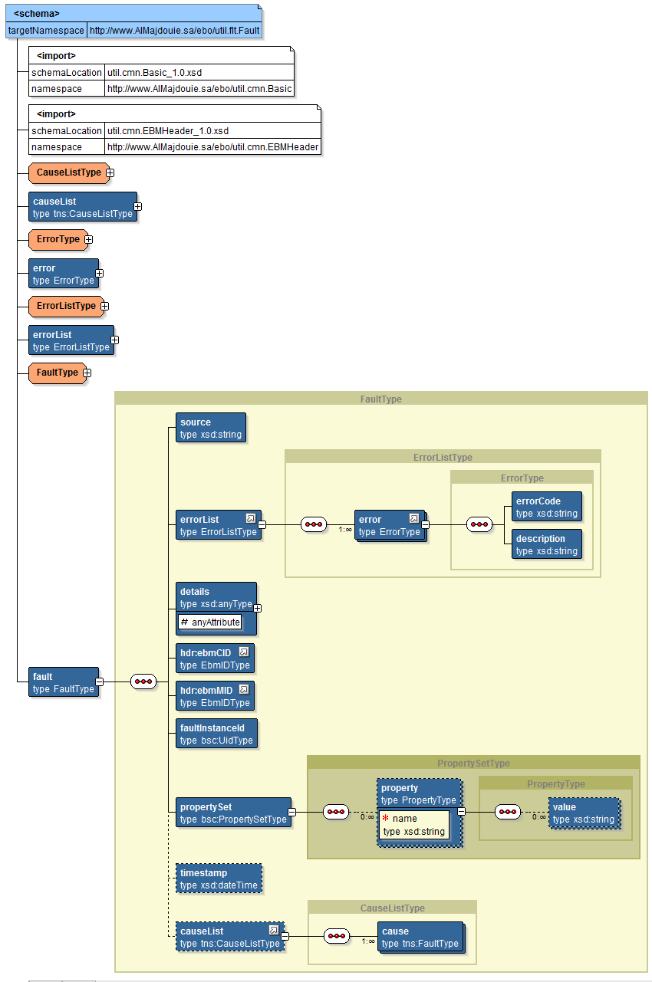

Figure 5: fault EBM

## Expected Errors

### Business Errors

| **Error Source** | **Error** | **Error Code Returned** | **Message Returned** | **Cause List** |
| --- | --- | --- | --- | --- |
| SOA | Unsupported operation | cs.pay:100 | Requested operation not found or supported | *Cause list not populated* |
| XQuery failure | cs.pay:400 | XQuery failure | *Cause list not populated* |
| Insert failure | cs.pay:401 | Insert failure | *Cause list not populated* |
| XML parsing error | cs.pay:402 | Failed to parse XML text | *Cause list not populated* |
| Context variable error | cs.pay:403 | Failed to set the value of context variable | *Cause list not populated* |
| Validation | Invalid request message | cs.pay:500 | Request message schema validation error | *Cause list not populated* |
| Invalid response message | cs.pay:501 | Response message schema validation error | *Cause list not populated* |
| Provider System | Missing / Invalid data | cs.pay:900 | Failed to get Sender ID, Reciever ID or Message Code from XML message. | *Cause list not populated* |
| Failed to read configuration file | cs.pay:901 | Failed to read SADADProfile.cnf file. | *Cause list not populated* |
| Invalid request message | cs.pay:902 | Failed to write the request message to Staging File System. | *Cause list not populated* |
| Failed to uncompress input data | cs.pay:903 | Failed to uncompress input data | *Cause list not populated* |
| Invalid header | cs.pay:904 | Invalid value for HTTP Header Content-Encoding.Expected 'gzip' | *Cause list not populated* |
| Failed to generate sfs file name | cs.pay:905 | Failed to generate SFS file name | *Cause list not populated* |
| Internal Error | cs.pay:998 | Internal error has occurred | *Cause list not populated* |
| Unexpected error | cs.pay:999 | Unexpected error in the provider system. | *Cause list not populated* |

### System Errors

| **Error Source** | **Error** | **Error Code Returned** | **Message Returned** | **Cause List** |
| --- | --- | --- | --- | --- |
| Network | Communication errors | cs.pay:200 | External transport error communicating with a provider. | *Cause list not populated* |
| Policy | Security policy fails | cs.pay:300 | Security policy failure. Ensure correct credentials are provided. | *Cause list not populated* |

### All Other Errors

| **Error** | **Error Code Returned** | **Message Returned** | **Cause List** |
| --- | --- | --- | --- |
| All other errors | cs.pay:001 | An unexpected error occurred | *Cause list not populated* |

## Operation –loadPayment

### Overview

| **Communication Style** | Synchronous request-response |
| --- | --- |
| **CRUD Operation/s** | Update |
| **Idempotent** | Yes |
| **Atomic** | Yes |
| **Transaction Required** | No |
| **Transaction Coordination Required** | N/A |
| **How Transaction Coordination Achieved** | N/A |

### Functional Overview



Figure 6: Functional Overview

### Security

The consumer will provide credentials enabling the consumer to consume the *loadBill* operation using Client Certificate Authentication over TLS.

### Input EBM

The input EBM is ***loadPayment*** and is in the XML namespace ***http://www.AlMajdouie.sa/ebs/cs.pay.Payments***. The figure below depicts this message.

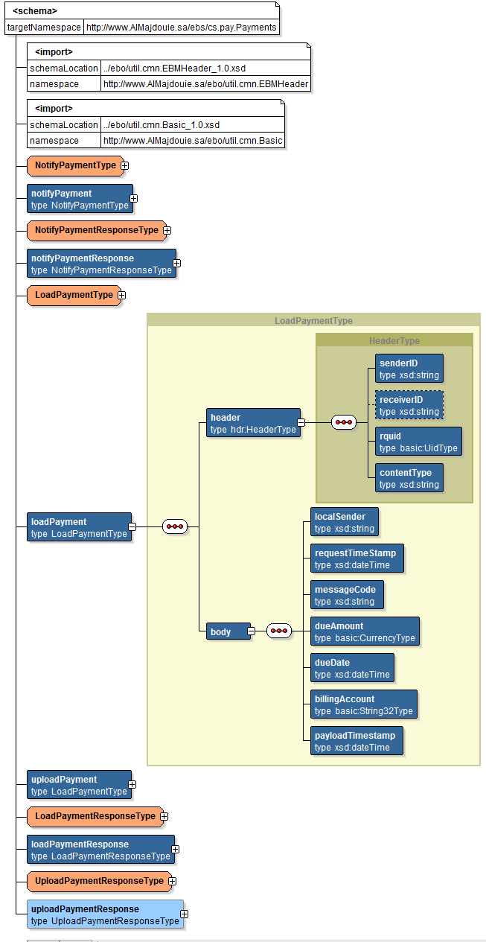

Figure 7: uploadPayment input EBM

### Output EBM

The output EBM is ***loadPaymentResponse*** and is in the XML namespace ***http://www.AlMajdouie.sa/ebs/cs.pay.Payments***. The figure below depicts this message.

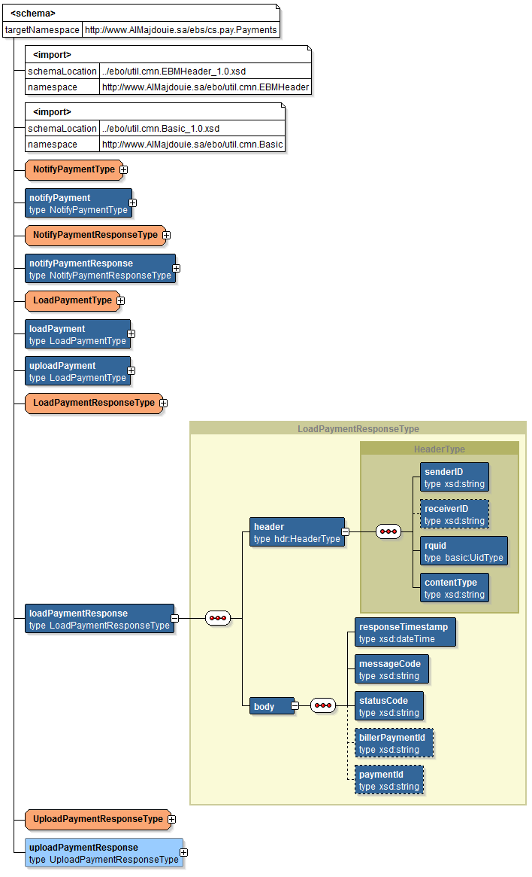

Figure 8: loadPaymentsResponse output EBM

### Fault EBM

The fault EBM is ***fault*** and is in the XML namespace ***http://www.AlMajdouie.sa/ebo/util.flt.Fault***. The figure below depicts this message.



Figure 5: fault EBM

## Expected Errors

### Business Errors

| **Error Source** | **Error** | **Error Code Returned** | **Message Returned** | **Cause List** |
| --- | --- | --- | --- | --- |
| SOA | Unsupported operation | cs.pay:100 | Requested operation not found or supported | *Cause list not populated* |
| XQuery failure | cs.pay:400 | XQuery failure | *Cause list not populated* |
| Insert failure | cs.pay:401 | Insert failure | *Cause list not populated* |
| XML parsing error | cs.pay:402 | Failed to parse XML text | *Cause list not populated* |
| Context variable error | cs.pay:403 | Failed to set the value of context variable | *Cause list not populated* |
| Validation | Invalid request message | cs.pay:500 | Request message schema validation error | *Cause list not populated* |
| Invalid response message | cs.pay:501 | Response message schema validation error | *Cause list not populated* |
| Provider System | Missing / Invalid sender-id or rquid | cs.pay:900 | Invalid Merchant Id | *Cause list not populated* |
| Invalid Merchant | cs.pay:901 | Merchant is not registered with SADAD | *Cause list not populated* |
| Invalid Customer Account Number | cs.pay:902 | Invalid Customer Account Number | *Cause list not populated* |
| Invalid Account | cs.pay:903 | The Account is not Active | *Cause list not populated* |
| Invalid Date format | cs.pay:904 | Payment Upload File date is in wrong format | *Cause list not populated* |
| Invalid date | cs.pay:905 | Payment Status Effective date cannot be a future date. | *Cause list not populated* |
| Invalid Date | cs.pay:906 | Payment Status Effective date is in wrong format | *Cause list not populated* |
| Invalid Date | cs.pay:907 | Payment Process date cannot be a future date | *Cause list not populated* |
| Invalid Date | cs.pay:908 | Payment Process date is in wrong format | *Cause list not populated* |
| Invalid Payment Amount | cs.pay:909 | The Payment Amount is invalid | *Cause list not populated* |
| Invalid Date | cs.pay:910 | The due date of the Payment is invalid | *Cause list not populated* |
| Invalid Payment | cs.pay:911 | Duplicate payment data | *Cause list not populated* |
| Invalid statment | cs.pay:912 | No associated Statement(s) exist for the Payment | *Cause list not populated* |
| Invalid/Missing data | cs.pay:920 | Failed to get Sender ID, Reciever ID or Message Code from XML message. | *Cause list not populated* |
| Invalid Bill Status Code | cs.pay:921 | Failed to get Signature value. | *Cause list not populated* |
| Bill Cycle does not exist | cs.pay:922 | Failed to get Certificate details from partner profile. | *Cause list not populated* |
| Invalid Expiry Date | cs.pay:923 | Failed to get message parameters from config file | *Cause list not populated* |
| Invalid active normal bill | cs.pay:924 | Failed to get partner profile from config file. | *Cause list not populated* |
| Payment completion failed | cs.pay:925 | Failed to read MessageDetails.cnf file | *Cause list not populated* |
| Internal Validation Error | cs.pay:926 | Failed to read PartnerDetails.cnf | *Cause list not populated* |
| Duplicate Statement | cs.pay:927 | Failed to validate the message | *Cause list not populated* |
| Deactivated Service type | cs.pay:928 | Verification failed for the certificate used for signing the data. | *Cause list not populated* |
| Deactivated Category | cs.pay:929 | Signature verification failed. | *Cause list not populated* |
| Invalid Bill Identification Rule | cs.pay:930 | Invalid XML. Schema validation failed. | *Cause list not populated* |
| Invalid statement number | cs.pay:931 | Failed to get Sender ID, Reciever ID or Message Code from XML message. | *Cause list not populated* |
| Invalid New one-off bill | cs.pay:932 | Failed to get Signature value. | *Cause list not populated* |
| Invalid Bill Number | cs.pay:933 | Failed to get Certificate details from partner profile. | *Cause list not populated* |
| Invalid Recurring category | cs.pay:934 | Failed to get message parameters from config file | *Cause list not populated* |
| Invalid currency value | cs.pay:935 | Failed to get partner profile from config file. | *Cause list not populated* |
| Invalid currency value | cs.pay:936 | Failed to read MessageDetails.cnf file | *Cause list not populated* |
| Invalid currency value | cs.pay:937 | Failed to read PartnerDetails.cnf | *Cause list not populated* |
| Duplicate RqUID | cs.pay:938 | Failed to validate the message | *Cause list not populated* |
| Invalid Bill | cs.pay:939 | Verification failed for the certificate used for signing the data. | *Cause list not populated* |
| Invalid state | cs.pay:940 | Signature verification failed. | *Cause list not populated* |
| Internal Error | cs.pay:998 | Internal error has occurred | *Cause list not populated* |
| Unexpected error | cs.pay:999 | Unexpected error in the provider system. | *Cause list not populated* |

### System Errors

| **Error Source** | **Error** | **Error Code Returned** | **Message Returned** | **Cause List** |
| --- | --- | --- | --- | --- |
| Network | Communication errors | cs.pay:200 | External transport error communicating with a provider. | *Cause list not populated* |
| Policy | Security policy fails | cs.pay:300 | Security policy failure. Ensure correct credentials are provided. | *Cause list not populated* |

### All Other Errors

| **Error** | **Error Code Returned** | **Message Returned** | **Cause List** |
| --- | --- | --- | --- |
| All other errors | cs.pay:001 | An unexpected error occurred | *Cause list not populated* |

## Operation – confirmPayment

### Overview

| **Communication Style** | Synchronous request-response |
| --- | --- |
| **CRUD Operation/s** | read |
| **Idempotent** | Yes |
| **Atomic** | Yes |
| **Transaction Required** | No |
| **Transaction Coordination Required** | N/A |
| **How Transaction Coordination Achieved** | N/A |

### Functional Overview



Figure 6: Functional Overview

### Security

The consumer will provide credentials enabling the consumer to consume the *confirmPayment* operation using Client Certificate Authentication over TLS.

### Input EBM

The input EBM is ***confirmPayment*** and is in the XML namespace ***http://www.AlMajdouie.sa/ebs/cs.pay.Payments***. The figure below depicts this message.

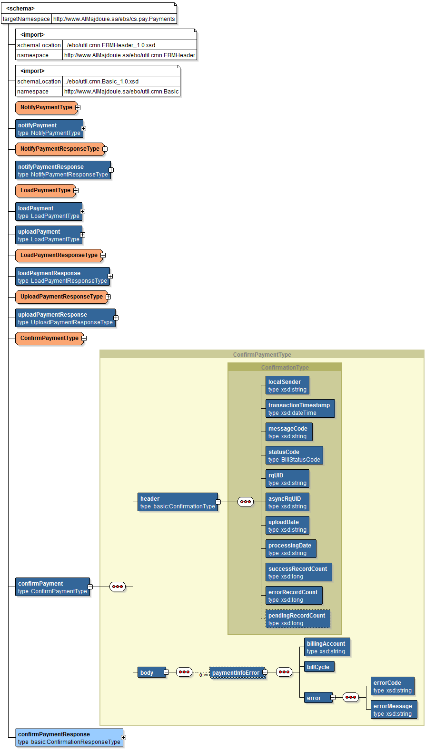

Figure 6: confirmPayment input EBM

### Output EBM

The output EBM is ***confirmPaymentResponse*** and is in the XML namespace ***http://www.AlMajdouie.sa/ebs/cs.pay.Payments***. The figure below depicts this message.

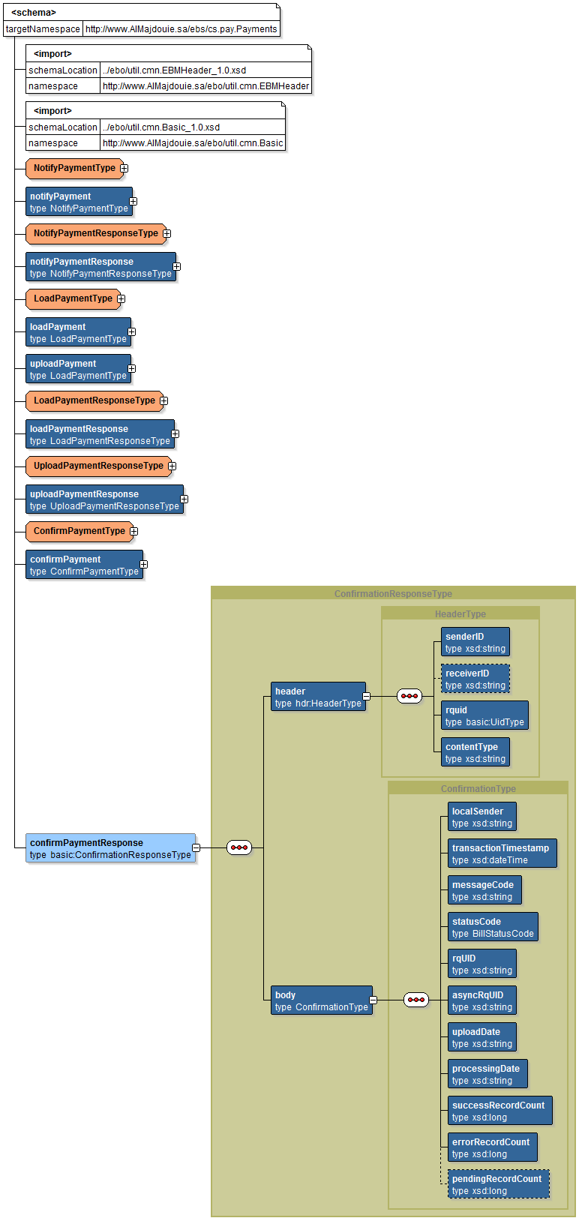

Figure 7: confirmPaymentResponse output EBM

### Fault EBM

The fault EBM is ***fault*** and is in the XML namespace ***http://www.AlMajdouie.sa/ebo/util.flt.Fault***. The figure below depicts this message.



Figure 8: fault EBM

## Expected Errors

### Business Errors

| **Error Source** | **Error** | **Error Code Returned** | **Message Returned** | **Cause List** |
| --- | --- | --- | --- | --- |
| SOA | Unsupported operation | cs.pay:100 | Requested operation not found or supported | *Cause list not populated* |
| XQuery failure | cs.pay:400 | XQuery failure | *Cause list not populated* |
| Insert failure | cs.pay:401 | Insert failure | *Cause list not populated* |
| XML parsing error | cs.pay:402 | Failed to parse XML text | *Cause list not populated* |
| Context variable error | cs.pay:403 | Failed to set the value of context variable | *Cause list not populated* |
| Validation | Invalid request message | cs.pay:500 | Request message schema validation error | *Cause list not populated* |
| Invalid response message | cs.pay:501 | Response message schema validation error | *Cause list not populated* |
| Provider System | Invalid request message | cs.pay:900 | Unable to parse corresponding request message | *Cause list not populated* |
| Invalid data | cs.pay:901 | Failed to get Sender ID, Reciever ID or Message Code from XML message. | *Cause list not populated* |
| value | cs.pay:902 | Failed to uncompress input data | *Cause list not populated* |
| Invalid value | cs.pay:903 | Invalid value for HTTP Header Content-Encoding.Expected 'gzip' | *Cause list not populated* |
| Invalid AsyncRqUID | cs.pay:904 | Invalid AsyncRqUID | *Cause list is populated for the embedded Error if it exists* |
| Generic Error | cs.pay:905 | Generic Error, see embedded Error Description | *Cause list not populated* |
| Internal Error | cs.pay:998 | Internal error has occurred | *Cause list not populated* |
| Unexpected error | cs.pay:999 | Unexpected error in the provider system. | *Cause list not populated* |

### System Errors

| **Error Source** | **Error** | **Error Code Returned** | **Message Returned** | **Cause List** |
| --- | --- | --- | --- | --- |
| Network | Communication errors | cs.pay:200 | External transport error communicating with a provider. | *Cause list not populated* |
| Policy | Security policy fails | cs.pay:300 | Security policy failure. Ensure correct credentials are provided. | *Cause list not populated* |

### All Other Errors

| **Error** | **Error Code Returned** | **Message Returned** | **Cause List** |
| --- | --- | --- | --- |
| All other errors | cs.pay:001 | An unexpected error occurred | *Cause list not populated* |

## Operation – notifyPayment

### Overview

| **Communication Style** | Synchronous request-response |
| --- | --- |
| **CRUD Operation/s** | read |
| **Idempotent** | Yes |
| **Atomic** | Yes |
| **Transaction Required** | No |
| **Transaction Coordination Required** | N/A |
| **How Transaction Coordination Achieved** | N/A |

### Functional Overview



Figure 6: Functional Overview

### Security

The consumer will provide credentials enabling the consumer to consume the *notifyPayment* operation using Client Certificate Authentication over TLS.

### Input EBM

The input EBM is ***notifyPayment*** and is in the XML namespace ***http://www.AlMajdouie.sa/ebs/cs.pay.Payments***. The figure below depicts this message.

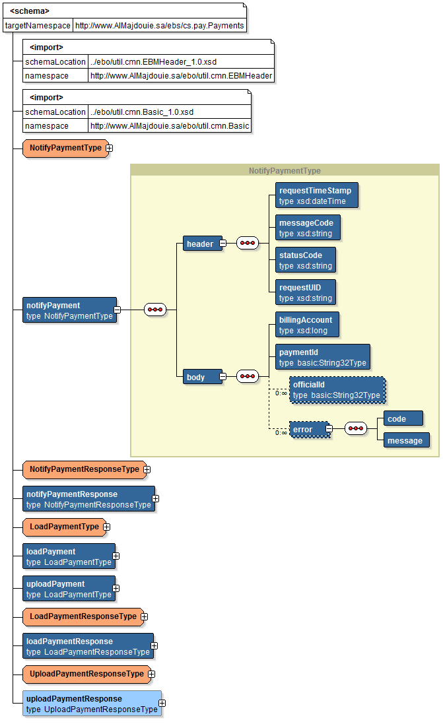

Figure 6: notifyPayment input EBM

### Output EBM

The output EBM is ***notifyPaymentResponse*** and is in the XML namespace ***http://www.AlMajdouie.sa/ebs/cs.pay.Payments***. The figure below depicts this message.

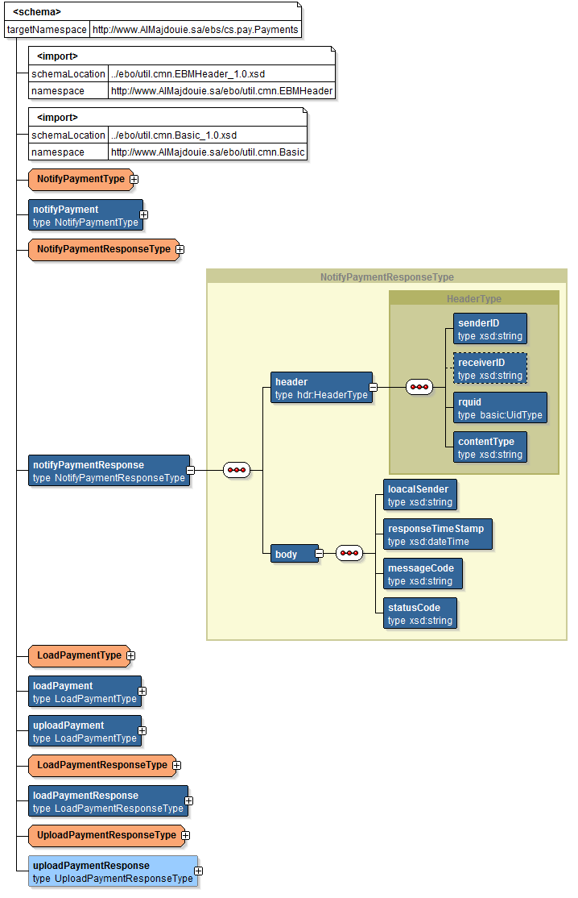

Figure 7: notifyPaymentResponse output EBM

### Fault EBM

The fault EBM is ***fault*** and is in the XML namespace ***http://www.AlMajdouie.sa/ebo/util.flt.Fault***. The figure below depicts this message.



Figure 8: fault EBM

## Expected Errors

### Business Errors

| **Error Source** | **Error** | **Error Code Returned** | **Message Returned** | **Cause List** |
| --- | --- | --- | --- | --- |
| SOA | Unsupported operation | cs.pay:100 | Requested operation not found or supported | *Cause list not populated* |
| XQuery failure | cs.pay:400 | XQuery failure | *Cause list not populated* |
| Insert failure | cs.pay:401 | Insert failure | *Cause list not populated* |
| XML parsing error | cs.pay:402 | Failed to parse XML text | *Cause list not populated* |
| Context variable error | cs.pay:403 | Failed to set the value of context variable | *Cause list not populated* |
| Validation | Invalid request message | cs.pay:500 | Request message schema validation error | *Cause list not populated* |
| Invalid response message | cs.pay:501 | Response message schema validation error | *Cause list not populated* |
| Provider System | Payment rejected | cs.pay:900 | One or more payments were rejected | *Cause list not populated* |
| Fail to uncompress data | cs.pay:901 | Failed to uncompress input data | *Cause list not populated* |
| Invalid value | cs.pay:902 | Invalid value for HTTP Header Content-Encoding.Expected 'gzip' | *Cause list not populated* |
| Internal Error | cs.pay:998 | Internal error has occurred | *Cause list not populated* |
| Unexpected error | cs.pay:999 | Unexpected error in the provider system. | *Cause list not populated* |

### System Errors

| **Error Source** | **Error** | **Error Code Returned** | **Message Returned** | **Cause List** |
| --- | --- | --- | --- | --- |
| Network | Communication errors | cs.pay:200 | External transport error communicating with a provider. | *Cause list not populated* |
| Policy | Security policy fails | cs.pay:300 | Security policy failure. Ensure correct credentials are provided. | *Cause list not populated* |

### All Other Errors

| **Error** | **Error Code Returned** | **Message Returned** | **Cause List** |
| --- | --- | --- | --- |
| All other errors | cs.pay:001 | An unexpected error occurred | *Cause list not populated* |

1. Add open issues that you identify while writing or reviewing this document to the open issues section. As you resolve issues, move them to the closed issues section and keep the issue ID the same. Include an explanation of the resolution.  
     
   When this work product is complete, any open issues should be transferred to the project- or process-level Issue Log (Manage focus area) and managed using a project level Issue Form (Manage focus area). In addition, the open items should remain in the open issues section of this work product, but flagged in the resolution column as being transferred.

# Appendix

|  |  |  |  |  |
| --- | --- | --- | --- | --- |
| Doc. S.No | Component | Document Description | Reference | Comments |
|  |  |  |  |  |